Guide to installing NOMADS software tools on Windows

While UNIX is the recommended environment for running NOMADS tools and most ONT processes, we recognize that many use Windows as their main operating system (OS). This guide describes the process of setting up the necessary applications in Windows.

# Installation

## mamba and git

1. Download the latest version of the Windows executable from the website (look for the Windows line in the table and click on latest, then look for ‘Miniforge3-Windows-x86_64.exe’): <https://github.com/conda-forge/miniforge>
2. To install git go to: <https://github.com/git-guides/install-git>, download the latest version (currently it is Git-2.47.0.2-64-bit.exe)
3. Install each of the downloaded files by clicking on them and following the on-screen prompts (unless there is a specific reason, the default options should be fine)

## NOMADS tools

1. In the Windows Start Menu, open the ‘MiniForge Prompt’ and you should get a picture like this:

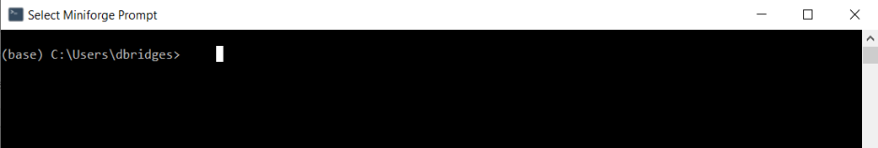

1. Clone the repository of interest to your local drive. I would recommend creating a folder called ‘git’ that you can store all of the repositories you are interested in. For this guide, I will install warehouse.

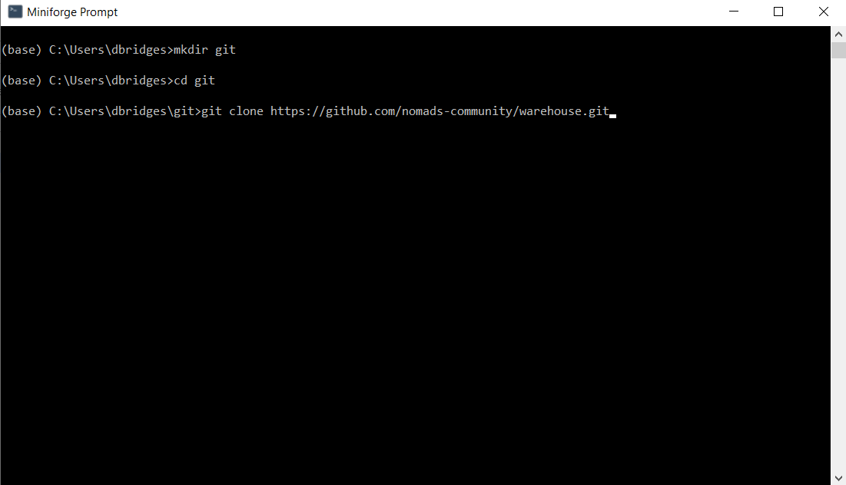

1. Now you can change directory (cd) into the warehouse directory, and create the environment:

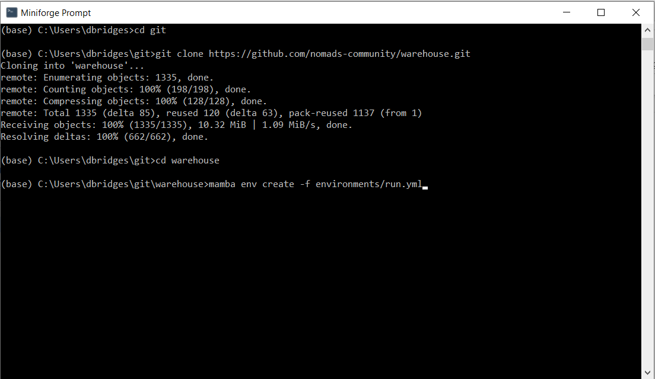

1. Once the environment is installed we activate it and install the local dependencies:

1. You should now be able to access warehouse:

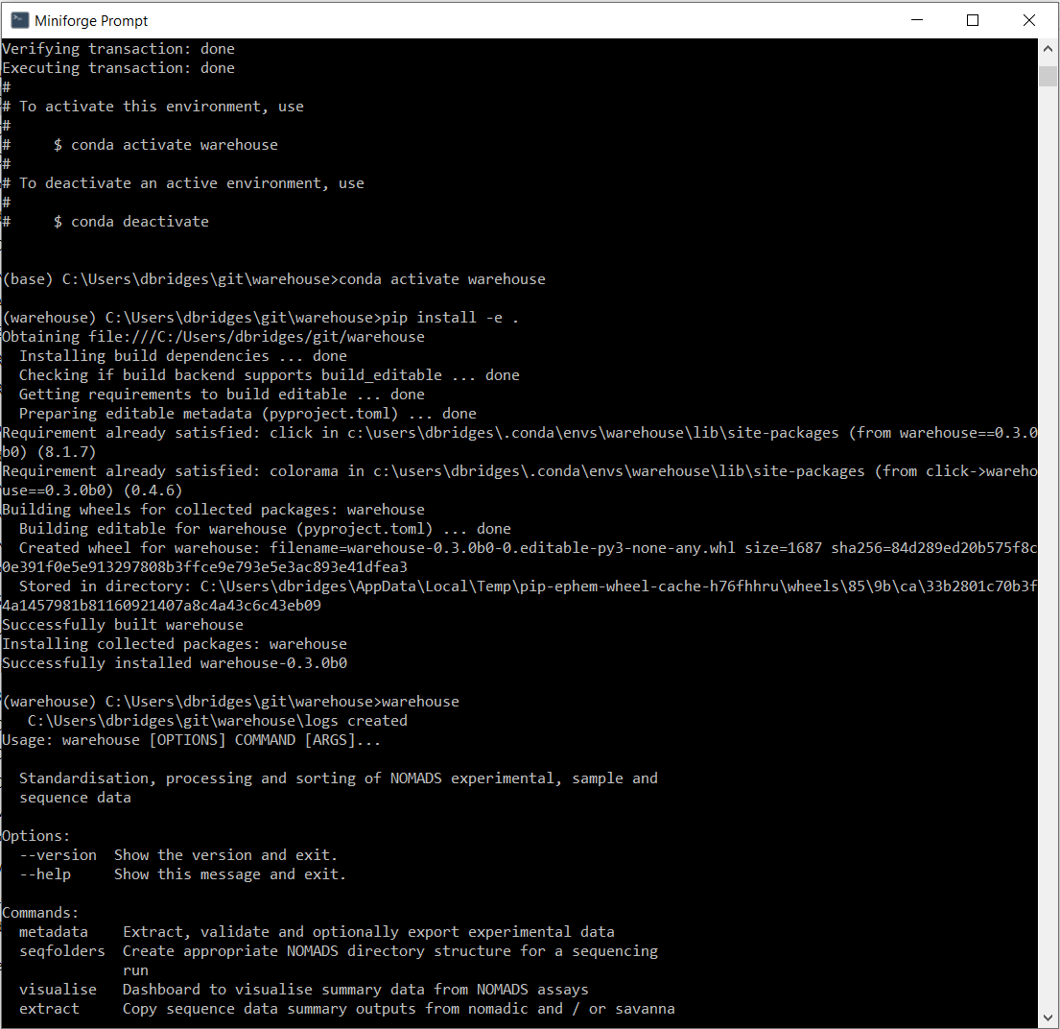

## Google Drive

NOMADS Collaborators data is stored on separate shared Google Drives. To access the data Google Drive for Desktop needs to be installed:

1. Download from <https://workspace.google.com/products/drive/#download>
2. Install and login to your Google Drive account
3. Navigate in Windows Explorer file browser to the shared Google Drive folder and select for offline access:

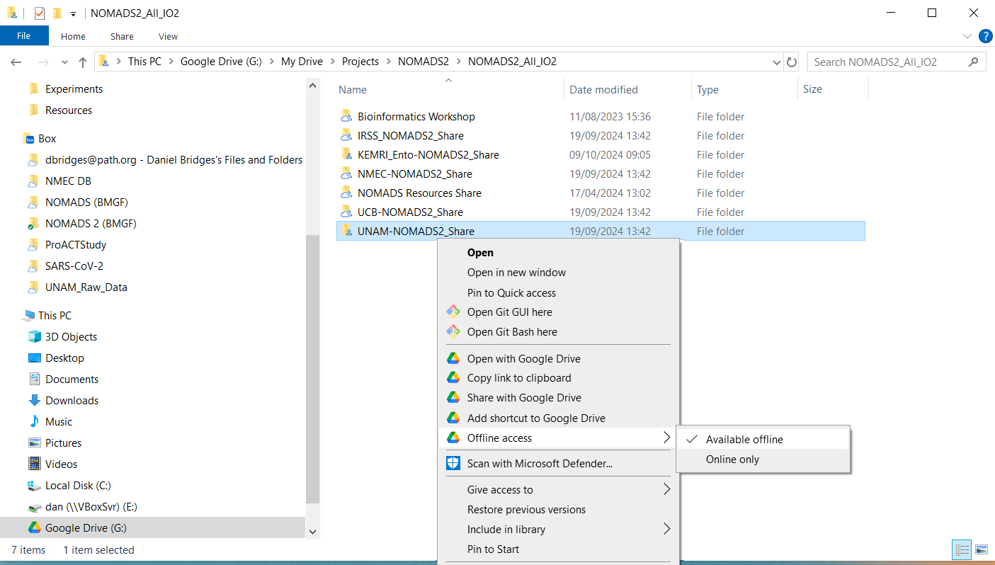

# Navigating the Windows CLI prompt

Unlike in Unix that has a root folder, there can be multiple drives with Windows and navigating them can be more challenging on the command line. One solution is to find the path to a folder using Windows Explorer and then clicking on the location bar to get the absolute path. For instance, here I click on Google Drive and navigate to a subfolder:



When I click on the location bar – the absolute path is shown:



If you copy this path and place it inside quotes (spaces are problematic on the command line and need to be protected) you can now reference the location correctly:

